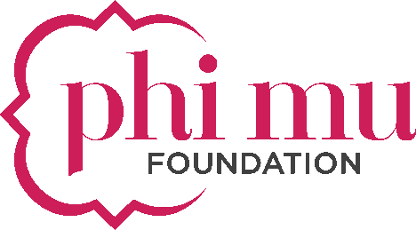
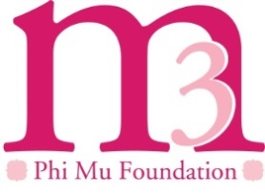
Alumnae Chapter
M3 Remittance Form

Submit this form, along with your donation(s) to:
Phi Mu Foundation, M3 Campaign Processing
400 Westpark Drive, Peachtree City, GA 30269

Name of Alumnae Chapter: _________________________________________________________________
Name of Person Submitting form: ____________________________________________________________
Email Address: ____________________________________________________________________________

Alumnae Fundraising Donation(s) and/or Other Contribution(s)
Complete the information below if your chapter is making a chapter donation to the M3 Campaign.
- Total Amount of Donation(s): $____________________________________________________________
- Check (or money order) Number(s):

Please include a brief description about your fundraising event:
_______________________________________________________________________________________________________________________________________________________________________________________________________________________________________________________________________________________________________________________________________________________________________________________________________

*If hosting a fundraiser with chapter member donations, please include member listing with contribution amount.

Attach additional pages if necessary. Email event photos to Jessi Horne, Foundation Communications Strategist, at jhorne@phimu.org.

