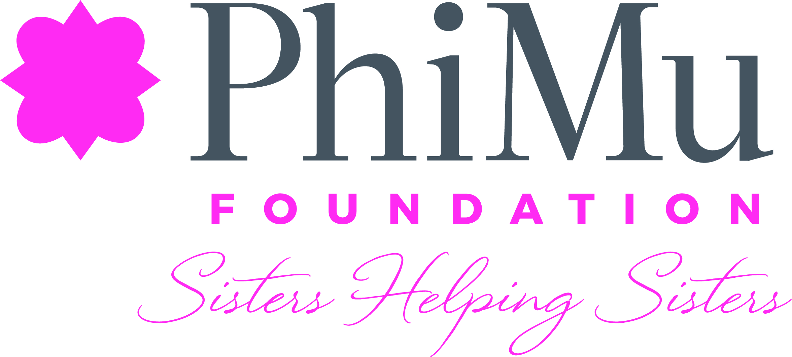

Leona Hughes Hughes Heart and Hand Fund
Personal Emergency Application

Instructions

The Leona Hughes Hughes Heart and Hand Fund provides emergency grants for collegiate and alumnae members of Phi Mu Fraternity who are in good standing and who experience financial emergencies due to natural disasters, medical situations or other severe personal or family issues. Grants do not need to be repaid; however, recipients must comply with the Foundation’s reporting requirements as based on Internal Revenue Service guidelines. Recipients may receive only one grant per calendar year. All applications are confidential.

In order for Phi Mu Foundation to maintain its tax-exempt status under the Internal Revenue Code, grants are provided to assist members with basic necessities such as food, clothing, housing, or extraordinary medical care not covered by insurance. Tuition assistance is provided through emergency scholarships available from the Foundation, although in some circumstances, education expenses, books and supplies may be eligible for assistance. National and Chapter Phi Mu Fraternity dues, obligations or social fees, and university Panhellenic fees are not eligible expenses.

Grant applications are evaluated by the Leona Hughes Hughes Heart and Hand Fund Committee, with the Phi Mu Foundation Board of Directors making final grant decisions. Applicants are accepted and evaluated on a continuous basis and applicants are not identified during the evaluation process. Grant amounts are based upon funds available.

All applicants must complete the appropriate application and sign the certification statement. This application is used for a request for a grant for situations other than a natural disaster. If your grant request is due to a natural disaster, please select that application from the Phi Mu Foundation website.

As a part of the application, applicants must submit two letters of support, one from a member in good standing of Phi Mu Fraternity and one from a community or caring professional who can attest to the facts presented in this application. The letters of support should be emailed directly to the Phi Mu Foundation Communications Strategist at jhorne@phimu.org from the individuals who wrote them.

The completed, signed application can be emailed to the Phi Mu Foundation Communications Strategist at jhorne@phimu.org. Please put “Emergency Assistance Application” in the subject line.

Questions regarding application procedures should be directed to the Phi Mu Foundation office at 770-632-2090.

Upon grant approval, the recipient should consult with a tax advisor to determine whether any funds received from the Foundation are taxable as income.
Leona Hughes Hughes Heart and Hand Fund
Personal Emergency Application

Part I: General Information

Name:________________________________________________________________________
First Maiden Last

Residence Address: _____________________________________________________________
Number Street Apt.#

______________________________________________________________________________
City State Zip Code

Contact Numbers:_______________________________________________________________
Home Cell Work

Date of Birth _________________________ Email _________________________________

Marital Status: Single Married Separated Divorced Widowed

If married, name of spouse: _______________________________________________________

Are your currently employed? Yes No Retired

Is your spouse currently employed: Yes No Retired

Are you insured against loss/illness? Yes No

If you are not employed, what are your employment prospects?
__________________________________________________________________________________________________________________________________________________________________________________________________________________________________________

If insured, please provide information regarding expected insurance coverage.
______________________________________________________________________________
______________________________________________________________________________
______________________________________________________________________________

Dependents:
Name Age Relationship
1._________________________ ________ __________________________
2._________________________ ________ __________________________
3._________________________ ________ __________________________
4._________________________ ________ __________________________

Please explain the circumstances for any listed dependent over the age of 21:
__________________________________________________________________________________________________________________________________________________________________________________________________________________________________________

Part II: Education and Phi Mu Information
College(s)/University(ies) Attended and Degrees Awarded:
1.____________________________________________________________________________
2.____________________________________________________________________________
3.____________________________________________________________________________

Chapter/University:_____________________________ Year Initiated:_____________________

If a collegian, describe your chapter involvement (offices held, committees, etc.): __________________________________________________________________________________________________________________________________________________________________________________________________________________________________________

If an alumna, describe your Phi Mu involvement since graduating (alumnae chapter membership, Phi Mu Foundation membership, advisory council service, area or national officer, etc.): __________________________________________________________________________________________________________________________________________________________________________________________________________________________________________

Part III: Grant Request

A. I am requesting a grant in the amount of ______________ for the following:
1._______________________________ $_________________
2._______________________________ $_________________
3._______________________________ $_________________
4._______________________________ $_________________
5._______________________________ $_________________
6._______________________________ $_________________
7._______________________________ $_________________
8._______________________________ $_________________
9._______________________________ $_________________
10._______________________________ $_________________

(Additional expenses may be added as necessary) Total $_________________

B. Please provide a personal statement describing the circumstances of emergency you
have experienced and the proposed use of any funds received through this grant. You
may add pages as necessary. Please be specific.

Part IV: Personal Financial Statement (this information is required to be in compliance with
Internal Revenue Service guidelines for 501(c)(3) organizations)

A. Monthly Income and Expenses
Monthly Income (Must include spouse's income unless separated or divorced):
Wages $_________
Social Security $_________
Retirement/Pension $_________
IRA (Average Monthly Withdrawal) $_________
Worker’s Compensation or Disability Payments $_________
Unemployment Compensation $_________
Average Monthly Income from Investments $_________
Income from Annuities $_________
Insurance Income $_________ Alimony or Spousal Support $_________
Child Support from Spouse $_________
Aid to Dependent Children $_________
Food Stamps $_________
Public Assistance $_________
Monetary Assistance From:
Parents $_________
Children $_________
Other Relatives $_________
Other Income (Describe) ________________ $_________
Total Monthly Income $_________
Monthly Expenses
Rent/Mortgage (including insurance/property taxes) $_________
Home Maintenance $_________
Groceries/Food $_________
Utilities (Gas, Electricity, Water, etc.) $_________
Cable $_________
Telephone (Home and Cell) $_________
Uninsured Medical Expenses $_________
Automobile Payment $_________
Gasoline/Maintenance $_________
Auto Insurance $_________
Loan payments $_________
Public Transit Costs $_________
Insurance:
Life $_________
Medical/Health $_________
Personal property $_________
Other Insurance $_________
Child Care $_________
Elder Care $_________
Credit Card Payments $_________
Student Loan Payments $_________
Other Loan/Debt Payment $_________
Clothing $_________
Other (Describe) $_________
Total Monthly Expenses $_________
B. Value of Assets. Itemize and identify current balances in all bank or savings accounts, credit
lines, brokerage accounts, 401Ks, IRAs, CDs, etc.
Description Amount
1. ______________________________________________ $ _____________
2. ______________________________________________ $ _____________
3. ______________________________________________ $ _____________
4. ______________________________________________ $ _____________
5. ______________________________________________ $ _____________
6. ______________________________________________ $ _____________

Real Estate:
Fair market value of your residence $ _____________
List balance of any mortgages $ _____________
Fair market value of any other real estate $ _____________
List balance of any mortgages $ _____________

If you expect receipt of any lump sum of money within the next year, such as inheritance, liability settlement, insurance proceeds, prize money, honorarium, royalties, donations, government lump sum assistance, monetary assistance from charitable organizations, etc., please state source and amount.
Description Amount
1. _____________________________________________ $ _____________
2. _____________________________________________ $ _____________
3. _____________________________________________ $ _____________

C. Financial Obligations
Outstanding Bills/Loans/Other Financial Liabilities
Description Amount
1. _____________________________________________ $ _____________
2. _____________________________________________ $ _____________
3. _____________________________________________ $ _____________

D. Other Pertinent Financial Information

E. When do you expect normal living expenses can be met without outside aid?

Part V: Letters of Support

You are responsible for obtaining two letters of recommendation in support of this application: one from a Phi Mu member in good standing and one from a community member or caring professional who can attest to the facts presented in this application. Please have the persons providing these recommendations send them to the address listed on the instruction page of this application. We are requesting the contact information should any questions arise.

Please list the contact information for the persons providing the letter of recommendation for this application:

1. Name:___________________________________________________________________

Telephone: ___________________________ Email: _______________________

Address: _________________________________________________________________

2. Name: ___________________________________________________________________

Telephone: ____________________________ Email: ________________________

Address:__________________________________________________________________

Part VI: Certification and Signature

I hereby certify and attest that the foregoing, including all financial information, is accurate. I understand and agree to provide further documentation as requested, which may include copies of bank and investment statements, documents to verify financial assertion, or income tax statements.
(If the applicant is unable to complete this form, her legal guardian with power of attorney may complete the application and sign below. A copy of the power of attorney must be attached to this application.) I further agree that, should I be selected for a grant, to use the funds for the purposed listed or approved only. Any unauthorized use of the funds may subject me to collection action.

Signature ____________________________________________ Date _________________

