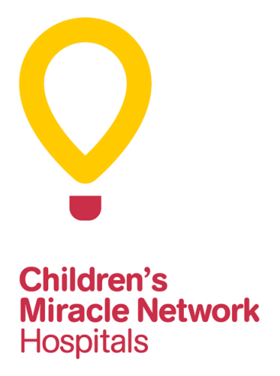
“Happy” Parker Lowden Children’s Miracle Network Hospitals
Internship Application

Applicant Criteria:
- Applicant must be an initiated Phi Mu in good standing.
- Complete the below application and include the following items:
  - Resume (include Phi Mu experience, work experience and academic activities).
  - A statement of how this internship will assist with future career plans.
  - An endorsement letter from the CMN Hospitals personnel who will serve as your supervisor.
  - A plan for service, which should be developed with CMN Hospitals personnel, and includes goals and objectives as well as specific tasks to reach the established goals.
  - Progress of work on organizing a campus/community fundraising event.

First Name: ____________________ Last Name: ____________________ Middle Initial: _____

Chapter: _______________________ Circle One: Freshman Sophomore Junior Senior

Permanent Address: _____________________________________________________________

City: _______________________________ State: ________ Zip: ______________________

Phone Number: ________________________ Email Address: _______________________
Please email/mail this form and supporting documentation to:
Phi Mu Foundation
ATTN: CMN Hospitals Internship Application
400 Westpark Drive Peachtree City, GA 30269
OR email to ktofanelli@phimu.org

Printed Name: _____________________________

Date: ____________________________________
Signature: _________________________________________________________________

Please direct all questions and correspondence related to your application to Kristin Tofanelli at ktofanelli@phimu.org or 770.632.2122.

